THEMENBLOCK 12: Music, Films & Entertainment

CATEGORY A: CONTRASTING IMAGES

TASK SET A1: The Cinema Experience vs. Home Streaming

PART 1 — Individual Long Turn (5 minutes)

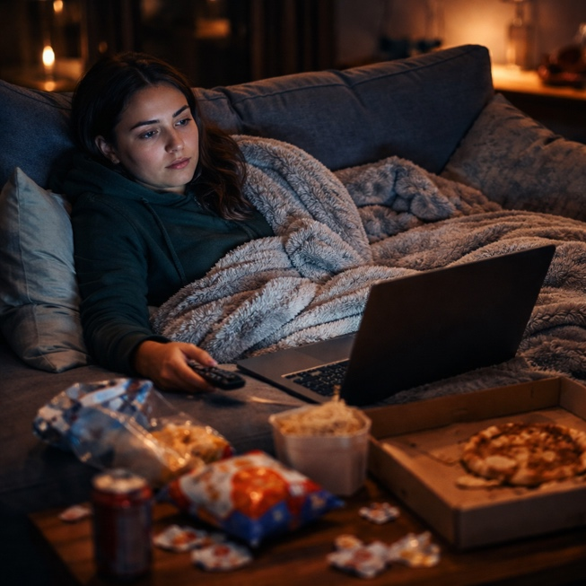

Task:
Give a five-minute talk on entertainment consumption in which you
- Describe, compare and contrast the two pictures above.
- Analyze the pros and cons of solo home viewing versus communal cinema experiences.
- Discuss which viewing experience you prefer and why.
─────────────────────────────────────────────────────────

PART 2 — Paired Activity
Scenario:
Your school is planning a "Discover Cinema" campaign to encourage students to visit local cinemas instead of only streaming at home. As members of the student council, discuss the following ideas for the campaign and agree on THREE to implement:

- Organize a "Cinema Club" with monthly group outings to see new releases
- Create social media content comparing the cinema experience to home streaming
- Partner with local cinemas for student discount programs
- Host a "Phone-Free Film Night" in the school auditorium
- Invite a film critic or director to speak about why cinema matters

TASK SET A2: Vinyl Revival vs. Digital Streaming

PART 1 — Individual Long Turn (5 minutes)

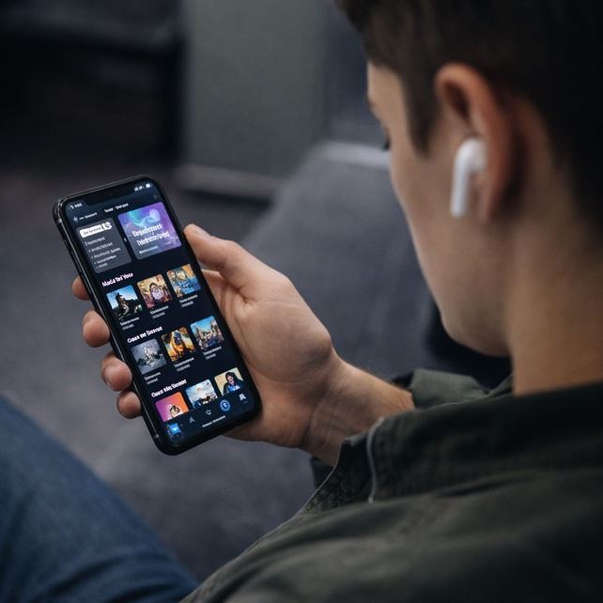
Task:
Give a five-minute talk on how we experience music in which you
- Describe, compare and contrast the two pictures above.
- Discuss whether vinyl and physical media can make a comeback.
- Comment on how music format affects appreciation and connection.
─────────────────────────────────────────────────────────

PART 2 — Paired Activity
Task:
Your school's music department is organizing a "Music Appreciation Week" to encourage students to engage more deeply with music. Discuss the following aspects and agree on THREE to prioritize
- Whether to include a vinyl listening session and how to source equipment
- Creating a "phone-free listening hour" where students focus on one album
- Inviting local musicians or DJs to discuss their relationship with music formats
- Setting up a "music swap" where students share physical CDs, records, or playlists
- Designing activities that encourage active listening vs. background music

TASK SET A3: Creating vs. Consuming Entertainment

PART 1 — Individual Long Turn (5 minutes)

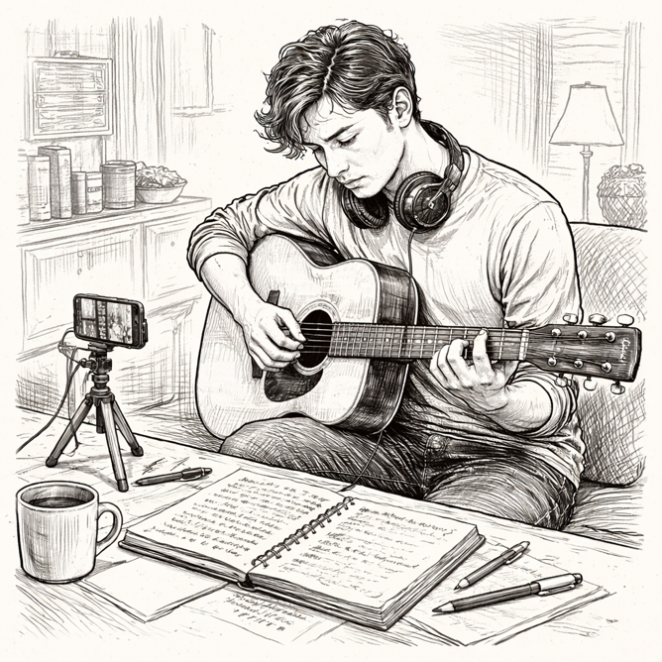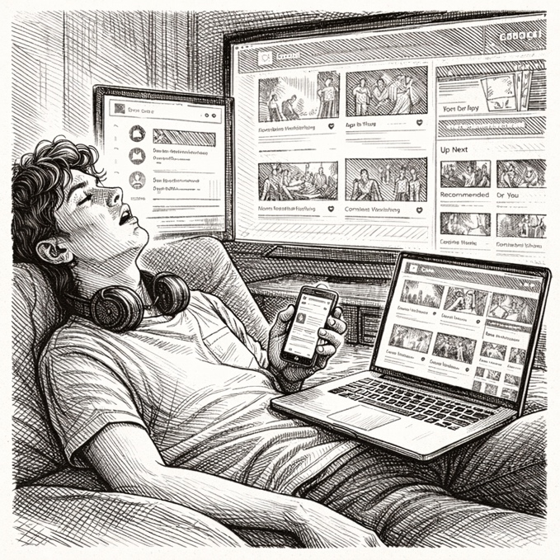
Task:
Give a five-minute talk on entertainment and creativity in which you
- Describe, compare and contrast the two pictures above.
- Discuss the psychological differences between actively creating something and passively consuming content.
- Outline strategies for balancing creative activities with entertainment consumption in daily life.
─────────────────────────────────────────────────────────

PART 2 — Paired Activity
Scenario:
Your school is conducting a research project on how students spend their free time. You and your partner need to develop interview questions for a survey. Discuss these potential questions and agree on THREE to include in the final survey:

- How many hours per day do you spend watching streaming content versus creating something (music, art, writing, etc.)?
- Do you feel more satisfied after binge-watching a series or after completing a creative project?
- Has social media and streaming changed how you spend your free time compared to five years ago?
- What barriers prevent you from engaging in more creative activities?
- Do you think schools should teach "digital wellness" as a subject?

CATEGORY B: QUOTES

TASK SET B1: Cinema in the Streaming Age: Art or Content?

PART 1 — Individual Long Turn (5 minutes)
Quote 1:
"The art of cinema is being systematically devalued, sidelined, demeaned, and reduced to its lowest common denominator, 'content.'"
— Martin Scorsese, Film Director
Quote 2:
"[Netflix] broke down walls as to who liked what, where and when."
— Ava DuVernay, Film Director
Task:
Give a five-minute talk on the future of cinema in which you
- Analyze the two quotes and explain what each filmmaker means by their statement.
- Evaluate whether streaming has helped or harmed the film industry.
- Comment on whether you value films differently based on viewing format.
─────────────────────────────────────────────────────────

PART 2 — Paired Activity
Scenario:
You have been invited to meet with the director of your local film festival. Before your meeting, discuss these potential topics and agree on THREE to raise with them:

- How to attract young audiences who primarily use streaming platforms
- Whether the festival should include content originally made for streaming services
- The importance of preserving the theatrical experience for audiences
- How technology (VR, immersive experiences) might change film festivals
- Supporting local and independent filmmakers in the streaming era

TASK SET B2: The Power of Shared Entertainment

PART 1 — Individual Long Turn (5 minutes)
Quote 1:
"I took one of my in-ears out and heard this giant arena filled with people singing it back to me... something about hearing that song is just so moving."
— Billie Eilish, Singer-Songwriter
Quote 2:
"I've always been such an album lover. I really love when something feels like one piece and is cohesive and thought-through."
— Billie Eilish, Singer-Songwriter
Task:
Give a five-minute talk on how we experience music and entertainment in which you
- Analyze both quotes and explain what Billie Eilish values about different entertainment experiences.
- Discuss how experiencing entertainment alone differs from shared experiences like concerts or cinema.
- Describe a personally meaningful experience of shared entertainment.
─────────────────────────────────────────────────────────

PART 2 — Paired Activity
Task:
Your school is organizing a "Screen-Free Weekend" initiative to encourage students to experience entertainment in more social ways. Discuss these organizational aspects and agree on THREE to focus on:
- Activities to offer: live music performances, outdoor cinema, game nights, sports events
- How to encourage participation without making it feel forced
- Addressing students who are reluctant to disconnect from streaming
- Measuring success: what would make this initiative worthwhile
- Plans for making this a regular event versus a one-time experiment

CATEGORY C: ALTERNATIVE PROMPTS

TASK SET C1: The Binge-Watching Generation

PART 1 — Individual Long Turn (5 minutes)

Text Extract
According to Nielsen's 2024 data, streaming now accounts for over 40% of all TV viewing in the United States, overtaking traditional broadcast television for the first time. Research indicates that 73% of viewers regularly binge-watch shows, with the average session lasting 3-4 hours. While streaming offers unprecedented choice and convenience, psychologists warn that extended viewing sessions may be linked to reduced sleep quality, increased feelings of isolation, and what researchers call "post-binge blues" — a sense of emptiness after finishing a series.
— Source: Nielsen, 2024
Task:
Give a five-minute talk on streaming and well-being in which you
- Explain what binge-watching is and why it appeals to young viewers.
- Discuss the health concerns mentioned in the extract are exaggerated or legitimate.
- Comment on how streaming has affected your generation's entertainment habits.
─────────────────────────────────────────────────────────

PART 2 — Paired Activity
Scenario:
Your school's debate club is preparing arguments on the topic: "Binge-watching does more harm than good." Take opposing positions and discuss these aspects:

- The psychological effects of watching multiple episodes in one sitting
- Whether streaming platforms intentionally design addictive features
- Personal responsibility versus corporate responsibility for viewing habits
- Whether age restrictions or time limits on streaming would be appropriate
- The social effects of everyone watching different shows at different times

TASK SET C2: Where Does Your Entertainment Time Go?
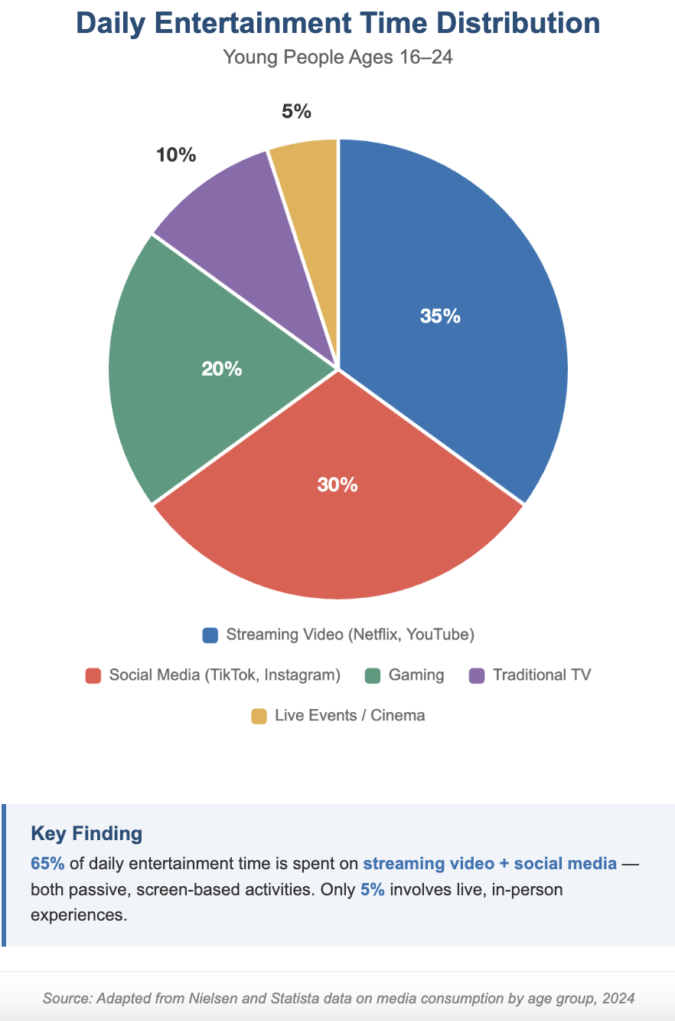
PART 1 — Individual Long Turn (5 minutes)

Task:
Give a five-minute talk on entertainment choices in which you
- Describe the data and what it reveals about young people's entertainment habits.
- Discuss why streaming and social media dominate while live events make up such a small percentage.
- Comment on whether you think this distribution is healthy and what, if anything, should change.
─────────────────────────────────────────────────────────

PART 2 — Paired Activity
Task: You are working with a media psychologist to develop recommendations for young people about healthy entertainment habits. Discuss these focus areas and agree on THREE to include in your final report:
- Setting daily screen time limits for different types of content
- The importance of including live, in-person entertainment regularly
- How to recognize when entertainment consumption becomes problematic
- Strategies for using entertainment more actively (discussion groups, creating content)
- The role of parents and schools in guiding entertainment choices

